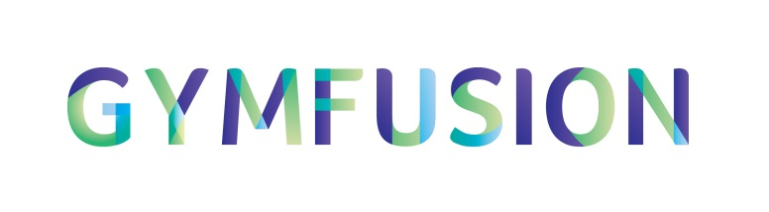
Music Upload Instructions

When you have input your gymnasts you will see this icon - .

By clicking on this icon you can upload the music that your team will use whilst competing in this Festival/GymFusion. You can upload a music file as long as it is one of these formats: MP3, M4A, OGG, WMA, WAV or FLAC.

As you are uploading music for a partnership/group you only need to upload the music once. Make sure to group your team together before uploading the team’s music as this means when you do upload the piece. Once you have done that you can select any gymnast to upload the music against and it will then the music will cascade to the other gymnasts in that team.

When you have completed uploading your music the icon becomes green indicating the music upload is OK.

